Assumptions

* **CLASS_CATEGORY CARDINALITY:**

I assumed that a class_category could be created, and not have any classes yet. So for example, the “Spin” class type/category could be created, because a spin room had just finished being built, and no specific classes existed yet, as spin instructors were working out the best times to set the upcoming spin classes, and once they quickly figured out the best times, they would then begin to populate the “SPIN” class category, with specific classes.

* **MEMBER_NAME COMPOSITE ATTRIBUTE:**

I assumed that the member_name composite attribute should be broken up into member_fname, and member_lname, as the client never explicitly stated NOT to break it up, and it may make certain queries easier (such as finding all members of a certain family, can simply search by last name).

* **BLOOD_PRESSURE COMPOSITE ATTRIBUTE:**

I broke up this attribute as well, because high blood pressure can be medically detected by either having a high SYSTOLIC number, OR high DISTOLIC number. Thus, breaking up blood pressure into 2 separate simple attributes, allows the client to more easily query their database, for all members that have high blood pressure, regardless of whether it be high systolic, or high diastolic (or both).

Potential reasons for why the client would want to perform a query like this: Targeted emails, to make advisements regarding certain exercises that have proven to help with high blood pressure, and other exercises that put them more at risk. Recommendations for personal training sessions, or even health evaluations if qualified staff are available.

Additional Comments

1. **Attribute Synthesis on Normalised Forms:**

The relation CLASS, and relation CENTRE, in the 3NF of the Class Staffing Reports, and Member Class Attendance Reports, both have the same PK, as shown in figure 1 and figure 2, thus they have been merged, (attribute synthesis), as shown in figure 3:

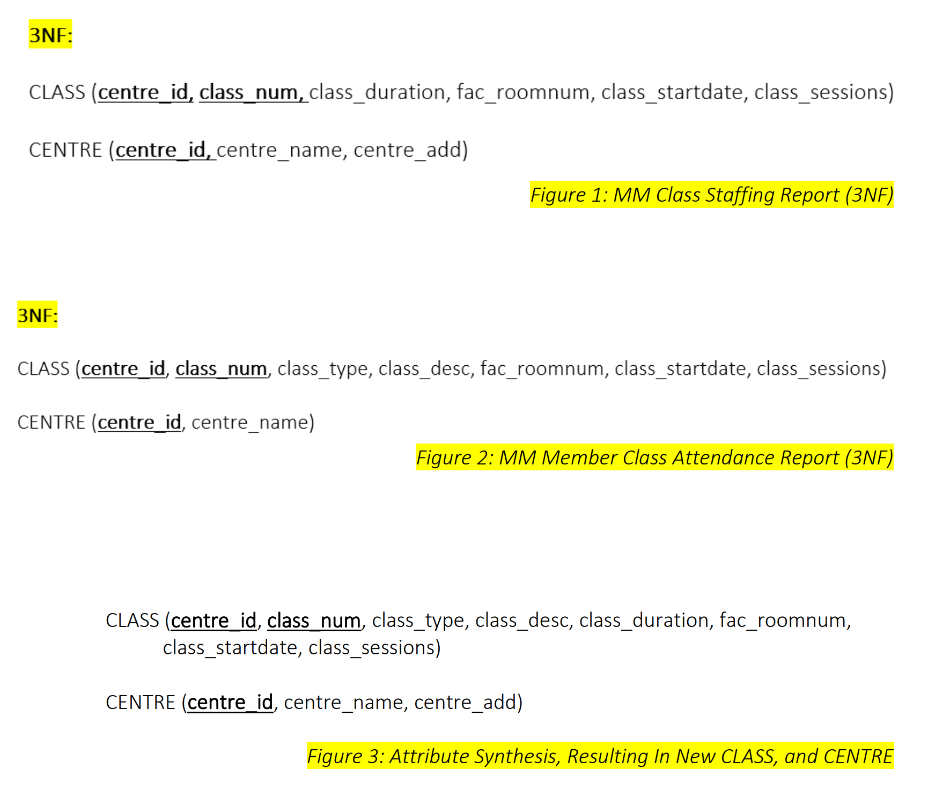

1. **Attribute Synthesis Between Conceptual Model, and Normalised Forms:**

The CLASS, CENTRE, CLASS_PAY, AID, and CLASS_STAFF relations in the 3NF of the Class Attendance Reports, and Class Staffing Reports, have identical PK’s to the existing relations in the logical model (that has come from the conceptual model). Thus, all of these relations have been merged into the existing relations.

In-fact, the only new relations that the normalised forms bring into the logical model, is SESSION_ATTENDANCE, and the lookup table, CLASS_CATEGORY.

1. **Surrogate key:**

A surrogate key was put into the relation, SESSION_ATTENDANCE, as it had attributes in its composite primary key, with two different data types (numeric and date).

However, I chose not to introduce a surrogate key into CLASS_STAFF, or CLASS_MEMBER, because despite both having 3 attributes as their composite primary key, which is quite large, all 3, in both cases, are NUMERIC. Thus the composite primary of these two relations, while large, is still simple, just pure numbers.

1. **Data Types of Attributes:**

I set all phone numbers to have datatype “VARCHAR”, instead of NUMERIC, as I do not think that the client will be performing any mathematical analysis on these phone numbers (of staff, members, or the centres). Same logic applied to postcodes.

1. **Constraints:**

I applied constraints to class_lead, staff_firstaid, and session_attendstatus, (in addition to the ones explicitly required by client), as these attributes could only be a few different values.